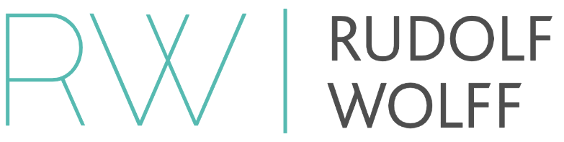
Rudolf Wolff Limited
50 Brook Street
Mayfair
London W1K 5DR

Terms of Business Checklist
In keeping with current legislation, Rudolf Wolff requires that all our business partners supply the necessary information and documentation to satisfy our compliance practices. We request that you answer all questions fully and attach certified copies of the documentation requested.
- Certified Certificate of Incorporation

- Utility / Bill showing owners/directors name and address. (POA)
(must be within the last 3 months)

- Bank Statement (company)

- Company signatories list

- Certified copy of in force Passport of all owners/directors. (POI)

- Certified copy of up to date License

- Principle Office of the Intermediary Address

Please submit these documents to our secure server at compliencedocs@rudolfwolff.com

